
{{report_title}}
Student Name: |  | {{student_name}} |  |  | Gender: | {{gender}}
Father's Name: |  | {{father_name}} |  |  | Roll Num: | {{roll_no}}
Mother's Name: |  | {{mother_name}} |  |  | Class: | {{standard}}
Age: |  | {{age}} |  |  | Year: | {{year}}
Address: |  | {{address}} Phone: {{contact_number}}
Subject | Max  Marks | Marks Obtained | Grade | Total Marks | Percentage | Remark
English |  | english |  | {{total_marks}} | {{percentage}} | {{remark}}
Maths |  | math |  | {{total_marks}} | {{percentage}} | {{remark}}
Science |  | science |  | {{total_marks}} | {{percentage}} | {{remark}}
Attendance |  |  | President of NEIEA
Total Classes: |  | {{total_classes}} | 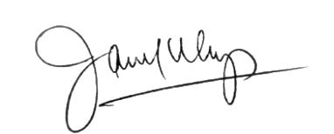
Classes Attended: |  | {{classes_attended}}
Attendance Percentage: |  | {{attendance_percentage}}
www.neiea.org

Note: This report has been generated electronically and is valid without a physical signature.

